TEST SUMMARY REPORT

CONTENTS

1.Purpose...............................................................................................................2
2.Application Overview..........................................................................................2
3. Reference Documents ...................................................................................... 2
4. Target Audience .................................................................................................2
5. Testing Scope ……………………................................................................................2
6. Metrics ................................................................................................................3
7. Types of Testing Performed................................................................................ 6
8. Test Environment and Tools................................................................................7
9. Exit Criteria ……………………………………………….........................................................7
10. Conclusion ……………………………………………………………………………………………….…...7

1. PURPOSE::-
This document explains the various activities performed as part of Testing of ‘Nobroker’ website.

2. WEBSITE OVERVIEW::-
“Nobroker” is a web-based application for online buying of properties and Rentals. It allows the user to buy,rent and commercial properties all the varieties of properties along with different types of properties and helps to so that the user is aware of each and every detail about theproperties. It also allows user to views bookings ,view receipts. There are several modules like login, help, rent ,buy,post your property and my bookings etc. which are integrated to fulfil the purpose.

3. REFERENCE DOCUMENTS::-
Test plan, Test case and Test scenarios documents

4. TARGET AUIDENCE::-
Project Manager, Release Team, Maintenance Team, Customer (End Users) and Client
5. TESTING SCOPE::-
a) In Scope::
- Login, Sign up
- Contact us
- About us
- Help
- Receipts
- My bookings
- Post your Properties
- Careers
- Search box
b) Out of Scope::
Performance Testing was not done for this application.
6. METRICS::-
Test Cases Planned | Test Cases Executed | Test Cases Passed | Test Cases Failed
11 | 11 | 11 | 0

Details of Passed and Failed Testcases

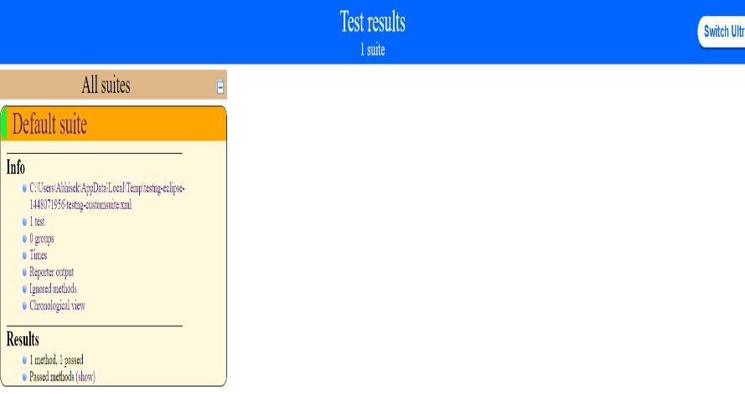

Passed TestCases::-

7. TYPES OF TESTING PERFORMED:;-
a) System Integration Testing : This testing is performed on the application under test i.e. Urban Ladder website to verify that the entire application works as per requirement. All the possible scenarios were tested to make sure important functionalities in the application works as intended without any errors.
b) Regression Testing : This testing is performed each time a new build is deployed for testing which contains defect fixes. This testing ensures that existing functionalities works fine after defect fix and new enhancements are added to the existing application. Test cases for new functionalities are added to the existing test cases and executed.

8. TEST ENVIRONMENT AND TOOLS::-

Application URL | https://www.nobroker.com/
Computer | Windows 10 Operating System, 8GB Ram
Testing tool | Selenium, Eclipse
Browsers | Chrome 102.0.5005.63

9. EXIT CRITERIA::-
a) All test cases should be executed - yes
b) All defects in Critical, Major, Medium severity should be verified and closed - yes
c) Most of the testcases must be passed - yes

10. CONCLUSION::-
As the Exit criteria was met and satisfied as mentioned in Section 9, this application is suggested to ‘Go Live’ by the Testing team. Appropriate User, Client/Business acceptance testing should be performed before ‘Go Live’.

